**Reporter**: Jason Zinoman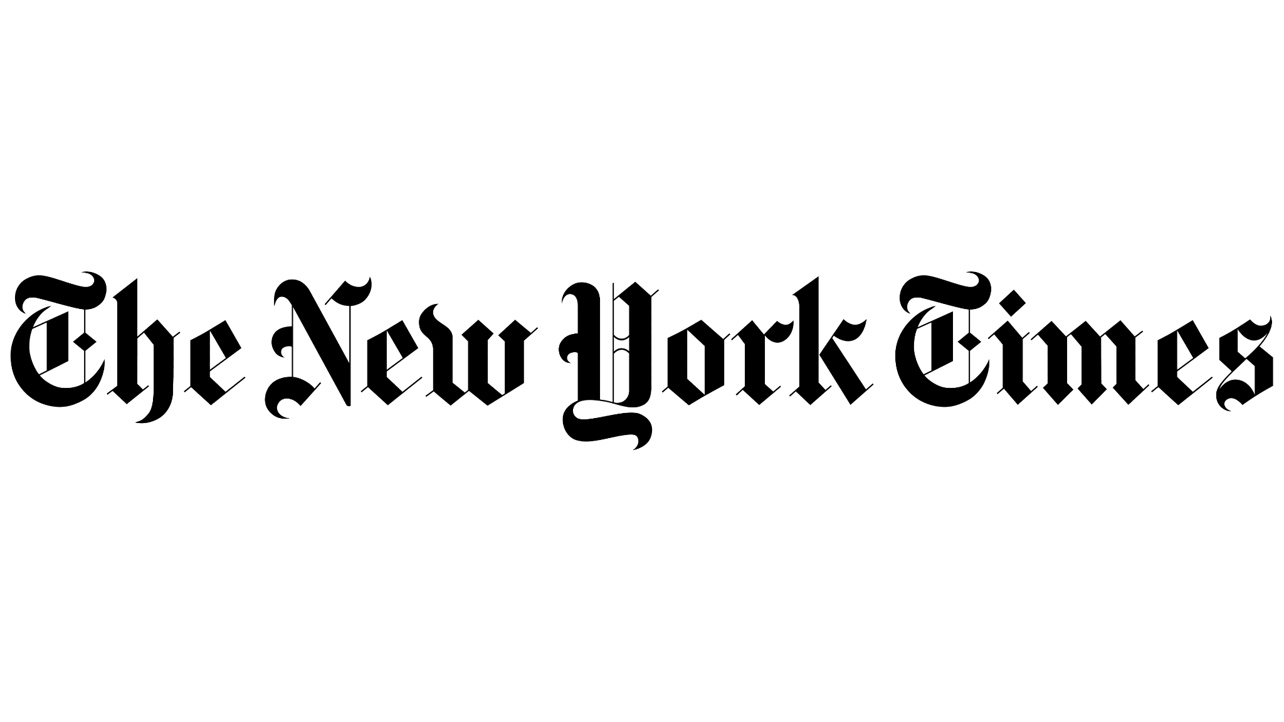

**Outlet**: The New York Times

**Title**: Critic at Large

**Socials**: [Instagram](https://www.instagram.com/zinomanj/), [Twitter](https://x.com/zinoman?lang=en), [LinkedIn](https://www.linkedin.com/in/jason-zinoman-330ba44/)

**Email**: [jason.zinoman@nytimes.com](mailto:jason.zinoman@nytimes.com)

**Date**: Tuesday, October 8, 2024

**Time**: 12:30pm ET

**Location**: Cheryl's Global Soul

**Address:** 236 Underhill Ave, Brooklyn, NY 11238

**About Jason:**

Jason is a critic and author, he has written for The New York Times, Time Out New York, Vanity Fair, and Slate. He currently is a critic at large for The New York Times, writing a column about comedy. Jason focuses on stand-up, but also covers improv, sketch, podcasts, plays, musicals, TikTok accounts, and other forms of comedy. His first magazine job was out Time Out NY, where he became chief theater critic and editor. Jason then began writing for The Times in 2003 on Broadway where he then transitioned to a theater critic covering Off Broadway productions. He then put out a book called “Shock Value” on Horror films and the same year began writing on the On Comedy column.

Jason is originally from DC and graduated from the University of Chicago.

**Meeting Goals**

* Get to know Jason in a casual setting and allow him to get to know you and your career. The purpose of this conversation is to introduce him to your past and current slate, what you’re building toward, and your unique place and point of view in the industry.
* Develop a relationship with this key reporter at The New York Times, down the line, when you have news to announce about upcoming projects, Jason might report on it or vice versa. When Jason is looking for an expert voice to weigh in on trends or breaking news stories, he might turn to you.

**Main Points/Overview**

1. **General Overview of your Work:** Share an overview of your history and background, your current slate and career-defining projects, and what’s next.
2. **Partnerships and Collaborations:** Discussing your work with well-known comedians can resonate with professionals in the industry, fostering a sense of connection and relatability.

**Recent press coverage from Jason**

* Jason’s coverage consists of comedy critics and comedy special reviews. He also discusses comedy podcasts, television, and important figures in the comedy world.
  + In August, Jason covered and [reviewed multiple](https://www.nytimes.com/2024/08/04/arts/television/joe-rogan-standup-netflix.html) [stand up comedy acts](https://www.nytimes.com/2024/08/27/arts/adam-sandler-love-you-netflix-special.html).
* In July, Jason wrote an article regarding the [future of the comedy industry regarding AI.](https://www.nytimes.com/2024/07/24/arts/television/simon-rich-saturday-night-live-glory-days.html)
  + This could be a good opportunity to offer your expertise as someone with a long tenure and deep experience in this industry

**Recent and Relevant Stories**

* September 24, 2024: [Ellen DeGeneres Is in Her Boss Era on Her New Netflix Special](https://www.nytimes.com/2024/09/24/arts/television/ellen-degeneres-netflix-for-your-approval.html)
* August 27, 2024: [Adam Sandler’s ‘Love You’ and Other Netflix Specials to Stream Now - The New York Times](https://www.nytimes.com/2024/08/27/arts/adam-sandler-love-you-netflix-special.html)
* August 25, 2024: [‘These Are Our Favorite Movies From 1999. What Are Yours?](https://www.nytimes.com/2024/08/25/movies/1999-movies-critics.html)
* August 9, 2024: [“Conner O’Malley’s Intensely Funny, Deeply Stupid Manosphere”](https://www.nytimes.com/2024/08/09/arts/conner-omalley-comedian.html)
* June 2, 2024: [“Is This Season of ‘Hacks’ Trolling Jerry Seinfeld?”](https://www.nytimes.com/2024/06/02/arts/television/jerry-seinfeld-hacks.html)

**Tips and Best Practices for Media Meetings:**

* We recommend familiarizing yourself with recent coverage – understanding what they are interested in covering and how you might mutually benefit the work you are each doing.
* Always good to ask during reporter meetings about their upcoming plans to see where we may be able to work together on secured coverage they already have slated. This also emphasizes your position as a coveted expert voice for them to turn to when they need data for their future articles or to ideate on insights you have that could shape upcoming coverage.
* Assume everything you say may make it into print, unless explicitly stated as **OFF THE RECORD** before saying it.
* If you don’t want to respond to a question or you’re uncomfortable answering -- it’s always fine to say, “I can get back to you on that,” or “I’m not sure,” and move on.