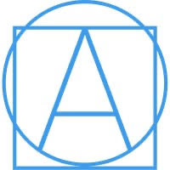

**About** [**Ad Astra Media**](https://www.adastramedia.org/)**:**

Ad Astra Media is a minority-owned production studio dedicated to creating diverse S.T.E.A.M. content for underrepresented communities from K to career. Their team seeks to inspire the next generation by showcasing opportunities in science, technology, engineering, arts, and mathematics.

Collaborating with organizations like Netflix, NASA, and the Clinton Global Initiative, we leverage digital platforms to reach diverse audiences. They specialize in VFX, animation, scripted content, and gaming, promoting inclusivity and representation in all our projects.

The company is committed to diversity and they foster an inclusive environment. Ad Astra Media aims to entertain, inspire, and ignite conversations that celebrate humanity's diversity.

**Socials:**

**Instagram:** @[adastramedia_org](https://www.instagram.com/adastramedia_org?igsh=MWo0N2J2aWw1eGI4OQ==) (1,353 followers)

**LinkedIn:** [Ad Astra Media, LLC](https://www.linkedin.com/company/adastrasteammedia/)

**About Jose Morey:**

Dr. Jose Morey, known as Dr. Intergalactic, founded Ad Astra Media in 2019 after observing the lack of diversity in S.T.E.A.M. careers during corporate meetings. His goal is to guide the next generation of innovators towards achieving equal representation in S.T.E.A.M. fields.

He serves as President of the Medical Society of Virginia Foundation and is the Chief Medical Officer for Ever Medical. An expert in exponential technology, Dr. Morey leads multidisciplinary teams in biotechnology, AI, and aerospace and is an advisor for organizations such as NASA, MIT, and the White House Office of Science and Technology. Recognized as the first Intergalactic Doctor, he has contributed to over 100 publications and has been featured in major media outlets like Forbes and CNBC. Additionally, he directs international engineering teams at Hyperloop Transportation Technologies and has played a significant role in AI healthcare innovations. Dr. Morey also holds academic positions at the University of Virginia and Eastern Virginia Medical School, and he actively participates in various advisory boards and initiatives.

**Jose’s Socials**

**Instagram:** [**@**drjosemorey](https://www.instagram.com/drjosemorey?igsh=cW83ZDZteXRscHo=)

**LinkedIn:** <https://www.linkedin.com/in/drjosemorey/>

**Ad Astra Media’s Services**

* **Animation**
* **Children’s Book Content:** Ad Astra Media delivers enchanting and educational children's media content that transports young viewers to worlds filled with wonder and curiosity around S.T.E.A.M.. With captivating characters, vibrant illustrations, and engaging storytelling, their content inspires young minds to explore, learn, and dream big. From imaginative adventures to valuable life lessons, Ad Astra Media creates a safe and uplifting space where children can laugh, learn, and grow through the power of media.
* **Virtual Reality:** Ad Astra Media transforms ideas into immersive virtual reality videos that captivate and engage audiences like never before. Harness the limitless potential of this cutting-edge technology and take your brand to new heights.
* **Illustration:** With a diverse range of illustration styles, from intricate pencil work to vibrant digital creations, Ad Astra Media has the versatility to cater to a wide array of creative projects. The team of talented illustrators combines artistic expertise with a deep understanding of clients' needs to deliver exceptional illustrations that captivate and inspire.
* **Storyboarding:** From thumbnail sketches to interactive storyboards, Ad Astra Media harnesses their expertise to provide clients with detailed and compelling visuals that effectively communicate your story, enhance the overall vision, and facilitate seamless production. Whether you're working on a film, animation, advertising campaign, video game, or another creative endeavor, our team is here to collaborate with you, transforming your ideas into vivid and dynamic visual representations.
* **Character Design:** We focus on bringing diversity and representation to all aspects of media. Equality through access and inclusivity - "If you can see it, you can be it!" We'll bring your unique and diverse characters to life!
* **Translation:** We are passionate about breaking down language barriers and connecting people from diverse cultures and backgrounds. We specialize in providing accurate and culturally sensitive translations in Spanish for a wide range of industries and purposes. Our team of linguists meticulously craft translations that capture the essence, nuances, and tone of the source material while ensuring clarity and precision in the Spanish language.
* **Consulting:** We specialize in providing top-notch consulting services to artists, studios, and businesses seeking to harness the power of animation. With a deep understanding of the industry and its evolving trends, our consultants offer invaluable guidance on everything from concept development and storytelling to production techniques and visual effects. Whether you're a budding animator or an established studio, Ad Astra Media is here to help you unlock your creative potential, elevate your projects, and achieve remarkable results in the world of animation.

**Notable Projects**

* **Animation**
  + [**Sombras**](https://www.adastramedia.org/sombras) **(silent film)**
    - Directed, animated, and produced: Marc “GIVE.ME.MÁS” Sánchez
    - Composed: Edgar Martínez Lozano
    - Executive Producer: Jose Morey
    - Distributed Through: Latino Public Broadcasting & AvendiaTV
  + [**Entre2Mundos**](https://www.adastramedia.org/entre2mundos) **(Latin Manga series)**
    - Executive Producers: Marc Sanchez, C.J. Zepeda, Brilla Media, Ad Astra Media
    - Entre2Mundos is a manga series and anime series of young kids traveling through a mysterious world based on Mesoamerica mythology. Their journey takes them to the 4 corners of this world as they uncover who they are and find their way back home.
  + **The Doctor is In (Animated series)**
    - Creators: Alyssa Harden, Sacha Smith, José Morey, Joel Bervell and Shelby Vaughn
    - Little Leland is a 5-year-old Black boy who’s so excited to grow up to be a doctor! He wants to be just like his role model, Dr. Joel Bervell, a local pediatrician who looks just like him. Together, Dr. Joel and Leland love explaining medical concepts to the audience. With the help of Dr. Joel's friendly, talking medical supplies, both Leland and the audience will learn something new!
* **Graphic Novels & Comics**
  + [**Labyrinths Borne**](https://www.adastramedia.org/labyrinthsborne)
    - Author: Frederick Luis Aldama
    - Creative Team: Itzel Argil Aguilar, Nicky Rodriguez, Renato Quiroga
    - Publisher ‏ : ‎ Ad Astra Media, LLC (February 9, 2024)
  + [**Intergalactic Academy Comics**](https://www.adastramedia.org/intergalactic-academy-comics)
    - Artist: Emily Tradwell
    - Writer: C.J Hudson, Elyse Russel
  + [**Terra Warriors**](https://www.adastramedia.org/terrawarriors)
    - Author: Alyssa Harden
    - Editor: Shelby Vaughn
    - Illustrator: Kevyn Kyle Dr. Intergalactic (Contributor), Susan Harden (Contributor)
    - Contributors: Susan Harden, Dr.Intergalactic
    - Publication Date: October 10, 2023
  + [**Good Night Series**](https://www.adastramedia.org/goodnightseries)
    - The Good Night Series is a culmination of Ad Astra Media's mission to show a diversity of individuals within various STEM and STEAM roles. Dr. Jose Morey says "We believe in the concept of 'if you can't see it you can't be it', so we want children of all backgrounds to know that anything is possible if they follow their STEAM dreams.
  + [**C.A.R.E Series**](https://www.adastramedia.org/careseries)
    - Ad Astra Media,'s newest children's book series entitled the C.A.R.E. Series (Conversation About Real Emotions)
* **Virtual Reality**
  + [**Conectado**](https://www.adastramedia.org/conectado)
    - Working with Conectado to bring their virtual world to life! In partnership with Tipping Point Media, we have built a 3D networking platform supporting diversity in S.T.E.A.M. and opening opportunities for career advancements in tech.
  + [**VR Application for CDC**](https://www.adastramedia.org/vr-application-for-cdc)
    - In partnership with MSV (Medical Society of Virginia) created a virtual reality application to improve the COVID-19 vaccination rates among children.
* **Documentary**
  + [**Chopin in Space**](https://www.adastramedia.org/chopin-in-space)
    - This 2021 documentary made by Ad Astra Media in collaboration with Alliance For Innovation and Chopin the Space Concert

**Upcoming**

* **“The Doctor Is In” Series**
  + New original series in the works
* [**Entre2Mundos**](https://kidscreen.com/2024/09/10/jorge-gutierrez-to-executive-produce-entre-2-mundos/)
  + Jorge Gutierrez (*The Book of Life)* to executive produce *Entre 2 Mundos* series with Ad Astra Media and Nuestro Stories.

**Awards**

**Won:**

* ***Sombras***
  + Phoenix Indie Film Festival - Best Director Best, Animated Film
  + Doc LA Los Angeles Documentary Film Festival - Best Animated Short
  + San Luis Film Festival - Best Overall Film
* **Chopin in Space**
  + Space Foundation - Awarded Creativity Certification Seal
* **Kulur Group Named Agency of Record**
  + Brand agency for “The Doctor Is In” series

**Relevant Articles**

* September 10, 2024: **Kidscreen**- [“Jorge Gutierrez to executive produce *Entre 2 Mundos”*](https://kidscreen.com/2024/09/10/jorge-gutierrez-to-executive-produce-entre-2-mundos/)
* August 6, 2024: **Business Wire**- [“Kulur Group Named Agency of Record for Ad Astra Media for "The Doctor Is In" Series”](https://www.businesswire.com/news/home/20240806931763/en/Kulur-Group-Named-Agency-of-Record-for-Ad-Astra-Media-for-The-Doctor-Is-In-Series)
* February 29, 2024: **Associated Press** - [“Ad Astra Media and Nuestro Stories Partner to Produce ‘Entre2Mundos’, a History-making Anime and Manga Series Inspired by Mesoamerican Civilizations and The Diaspora”](https://apnews.com/press-release/news-direct-corporation/television-animation-and-comics-movies-99ac48cf9abce6cb42a10360c72929c2)
* June 22, 2022: **Forbes -** [“Web3 And The Future Of Medicine”](https://www.forbes.com/councils/forbestechcouncil/2022/06/22/web3-and-the-future-of-medicine/)
  + Dr. José Morey wrote this article.
* July 22, 2021: **Forbes**- [“From El Fuego To Innovation”](https://www.forbes.com/councils/forbestechcouncil/2021/07/22/from-el-fuego-to-innovation/)

[**Ad Astra Media Team**](https://www.adastramedia.org/about)

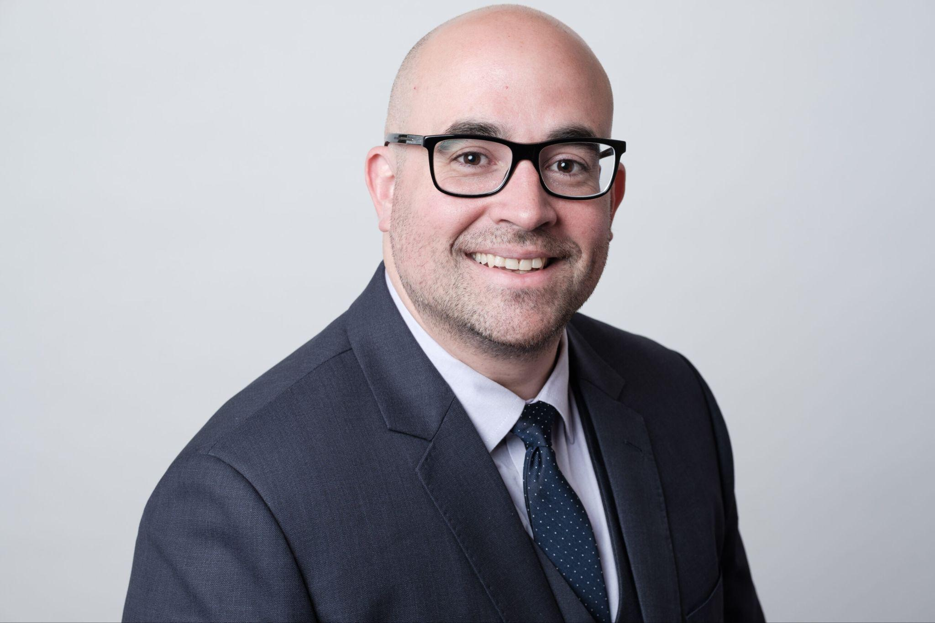

**Dr. Jose Morey, Founder and CEO**



**Lauren Kidd, Chief of Creative Operations & Executive Assistant**



**Shelby Vaughn, Chief Design Lead, Project Manager**