***News Release***

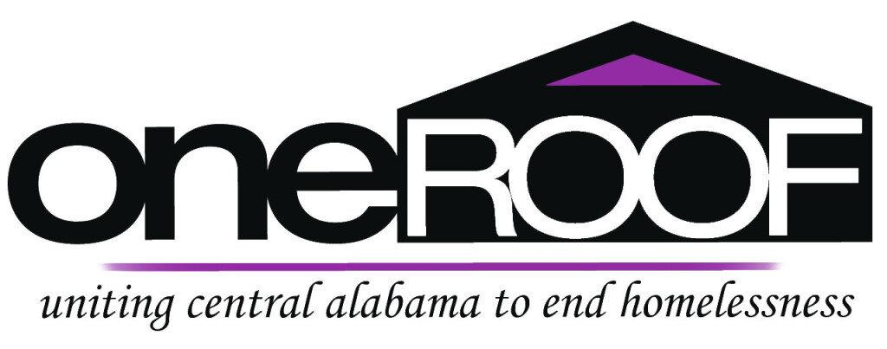

**2024 Point in Time Count for One Roof**

BIRMINGHAM, Ala (March 12, 2024) — The non-profit One Roof works to end homelessness in central Alabama through their annual point-in-time count which analyzes the current amount of homeless people in central Alabama and their urgent needs.

One Roof is based in central Alabama and is conducting a point-in-time census that provides an annual count of sheltered and unsheltered people experiencing homelessness in one single night. This census allows One Roof to figure out how to [make Central Alabama a place where no man, woman, or child has to experience homelessness.](https://www.oneroofonline.org/point-in-time-count#:~:text=PIT%20is%20an%20annual%20mini,child%20has%20to%20experience%20homelessness.)

The point-in-time count not only conducts how many homeless people are in the area but it helps the community better understand the needs of these homeless people.

“The number of veterans, youth, and individuals facing chronic homelessness each increased year over year. Homelessness among the Black community increased, while homelessness in the white community saw a slight decline” says Lee Hedgepeth of CBS 42.

While the point-in-time count can often be slightly inaccurate because it is not an exact science, it is often the only method to get a reasonable understanding of the amount of homeless people in an area.

There is often no other way to count homeless people so most areas, including One Roof, [just use a sample](https://abcnews.go.com/US/accurate-annual-count-us-homeless-population-misses-large/story?id=106671876).

Michelle Farley, One Roof’s executive director, said that “the survey is likely a significant undercount because it reflects only a brief, 24-hour snapshot of who is facing homelessness”.

One Roof and other non profit homeless organizations continue to advocate for the use of point-in-time counts regardless of accuracy because as of now, it is the only method for counting homeless people in areas like central Alabama and has helped many homeless people in the past get the help they need.

The point-in-time count wouldn’t be able to happen without the help of many volunteers conducting surveys in the area.

**About One Roof**

One Roof is the coordinating agency for the homeless Continuum of Care of central Alabama. As a continuum organization, One Roof is responsible for submitting central Alabama’s collaborative application through HUD’s Continuum of Care program, providing nearly $10 million in supportive housing programming for individuals and families experiencing homelessness.

Ellie Andrews

PR Practitioner

One Roof

Eha0012@auburn.edu

<https://www.oneroofonline.org/>