**Issue Backgrounder Ellie Andrews**

**Introduction**

*Veterans suffering from trauma and PTSD have a positive correlation with homelessness, which is an issue that One Roof, an organization working to end homelessness in central Alabama is passionate about. Cumulative trauma exposure has an impact on raising the chances of veterans becoming homeless and therefore there should be an improvement of housing outcomes and mental health assistance for veterans struggling with trauma and PTSD. This backgrounder details how homelessness affects veterans of all demographics and psychographic groups, the trauma and outcomes of trauma exposure, and how we can help these veterans by offering more mental health aid and more housing outcomes.*

**Overview**

Homelessness is an issue that affects people all over the U.S making up about 580,000 members of the population and according to [Pine Street Inn](https://www.pinestreetinn.org/news_events/facts_about_homeless_veterans) “about one-third of the adult homeless population are veterans”. Veterans struggling post-war are constantly at risk for homelessness due to “poverty, lack of support networks, and dismal living conditions in overcrowded or substandard housing”.

One Roof is an organization in central Alabama that's core mission is to end homelessness in this area. [One Roof](https://www.oneroofonline.org/advocate) is continuously “advocating for innovative solutions to homelessness, affordable housing, and improved services for people experiencing homelessness” in this area. Since a large population of homeless individuals are veterans it is important for One Roof to advocate and provide help for all homeless individuals including the portion of individuals that are veterans.

According to the article, [Cumulative Trauma Exposure and Chronic Homelessness Among Veterans: The Roles of Responses to Intrusions and Emotion Regulation](https://pubmed.ncbi.nlm.nih.gov/32662141/), “Veterans with mental health problems and a history of interpersonal and military trauma exposure are at increased risk for chronic homelessness”. With veterans making up such a large population of homelessness throughout central Alabama and the entire nation, it is important to understand why veterans are at such a large risk for homelessness. This article explains how the effects of cumulative trauma exposure in the military and effects of PTSD can have an affect on veterans mental health and emotional problems. The article completes a survey with 239 veterans of all different statuses in community-based homeless programs, and the findings concluded how “trauma-related factors that may be particularly relevant to episodic patterns of homelessness and interfere with efforts to remain housed”.

**How does homelessness affect veterans of all statuses?**

When understanding about the veteran's homeless population it is important to have an understanding of the population as a whole and how it is not just for one type of veteran. In fact, the veteran population is composed of veterans of all races, genders, relationship status, military service eras, and military branches. This means that any veteran can be subject to homelessness especially if they suffer from trauma exposure.

*How is veterans homelessness impacted by demographic status?*

While demographic status for veterans does not directly impact who is at greater risk for becoming homeless, it is still important to understand how it makes up the population of homeless veterans. According to some statistics from [Statista](https://www.statista.com/topics/3450/veterans-in-the-united-states/#topicOverview), more than 90% are men, more than 50% are white, around 30% are African American, and the highest concentration of homeless veterans live in California.

*How does military status impact homeless veterans?*

Although trauma varies for all veterans differently, understanding their military background including their service eras, military branches, and positions in the military plays an important role in understanding more about the veterans who are subject to homelessness. Understanding these veterans’ military status gives us a better understanding of how active they were in the war and how much trauma they were subject to. The amount of trauma they were subject to, whether it be in combat or non-combat, can have an effect on their mental and emotional health leading to stronger chances of homelessness.

**How does trauma affect veterans and lead to homelessness?**

When understanding how trauma affects veterans it is important to understand that these veterans don’t always come from a war zone, and many veterans also experience trauma in non-combat situations. Trauma can be caused by a variety of things and it is extremely important to know that everyone experiences trauma differently and reacts differently.

*How does PTSD (Post Traumatic Stress Disorder) contribute to homelessness?*

PTSD is a post traumatic stress disorder in which veterans who have experienced previous trauma can lead veterans to constantly feel on edge and “drive people away from their families, friends, and jobs'' according to the [Berry Law](https://ptsdlawyers.com/ptsd-homeless-veterans/). After the military, many veterans experience a challenging transition from the military back to everyday life. Veterans who become homeless often don’t seek help or feel that they are unable to, which often leads to self-medicating. Self-medicating for veterans can include substance abuse, alcoholism, or continuing to isolate themselves. The feeling of neglect, lack of support, and attempting to treat their trauma themselves are factors that ultimately lead most veterans to homelessness.

*How does MSA (Military Sexual Assault) contribute to homelessness?*

MSA is a non-combat form of trauma that also has major impacts on veteran homelessness. The [University of Chicago Press Journals](https://www.journals.uchicago.edu/doi/full/10.1086/712991) notes that “41% of females and 5% of males reported experiencing MSA” in a community sample of non-treatment seeking veterans. MSA is an extremely important issue that has been evaluated and found to be “significantly associated with higher levels of posttraumatic stress disorder (PTSD), depression, anxiety, alcohol use, substance use, and adjustment disorders as well as poorer family relations and lower quality of life”. MSA is a form of PTSD for many female veterans and some male veterans and leads to homelessness in similar ways.

**How can we help veterans who are experiencing homelessness?**

Although homelessness for veterans can be something that seems hard to prevent and hard to beat, there are always ways to help, whether it be small or big. According to the [National Coalition for Homeless Veterans](https://nchv.org/how-you-can-help/), anyone can help through supporting emergency shelters, volunteering as mentors and counselors, volunteering at programs, etc. Although anyone can help in small ways in order to have a long-lasting effect on helping homeless veterans there needs to be more mental health aid opportunities and more housing outcomes in order to prevent veteran homelessness for the future.

*How can mental health aid help homeless veterans?*

In order to prevent veterans from becoming homeless or to help veterans who are already homeless get back on their feet, having more mental health aid opportunities specifically for veterans is one of the best ways to help. By having more access to mental health resources, veterans will be able to properly treat and aid their trauma. There are some already in place such as the HCHV program with the [U.S. Department of Veteran Affairs](https://www.va.gov/homeless/mental_health_services.asp), which is put in place to offer “outreach, exams, treatment, referrals, and case management” for homeless veterans dealing with trauma and mental health issues. Although the HCHV program is great for homeless veterans there needs to be more opportunities like this available and accessible for homeless veterans in all areas.

*How can more housing outcomes help homeless veterans?*

Homeless veterans can greatly benefit from having more housing outcomes available to them whether it is when they are coming out of the military or they are already homeless. In the article, [How Homelessness Programs are Serving Four Populations In California](https://ternercenter.berkeley.edu/research-and-policy/distinct-populations-homelessness-programs/), the VHHP (Veterans Housing and Homelessness Prevention Program) worked to provide funds that contributed towards developing affordable housing for veterans. They found that through these actions “the number of veterans experiencing homelessness in California declined 41% between 2010 and 2022”, which shows that more housing outcomes would be a positive opportunity for homeless veterans.

**Photos and Visuals as Needed**

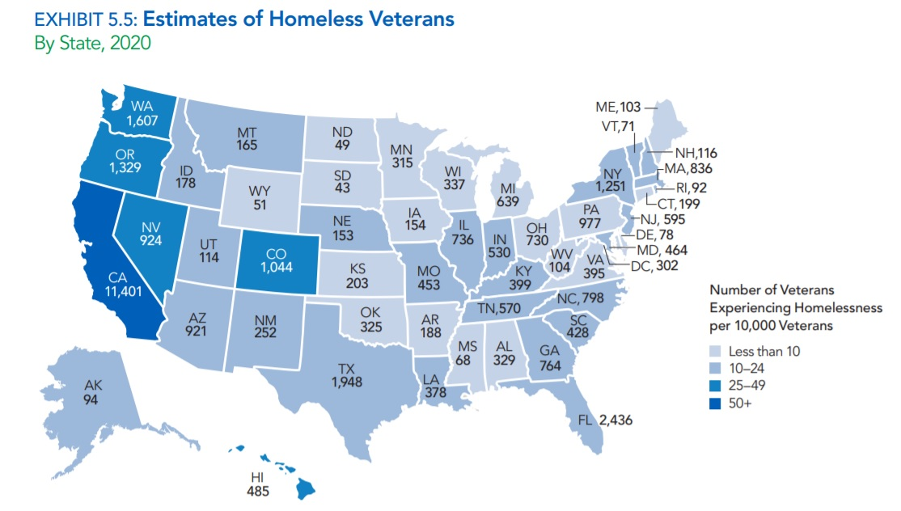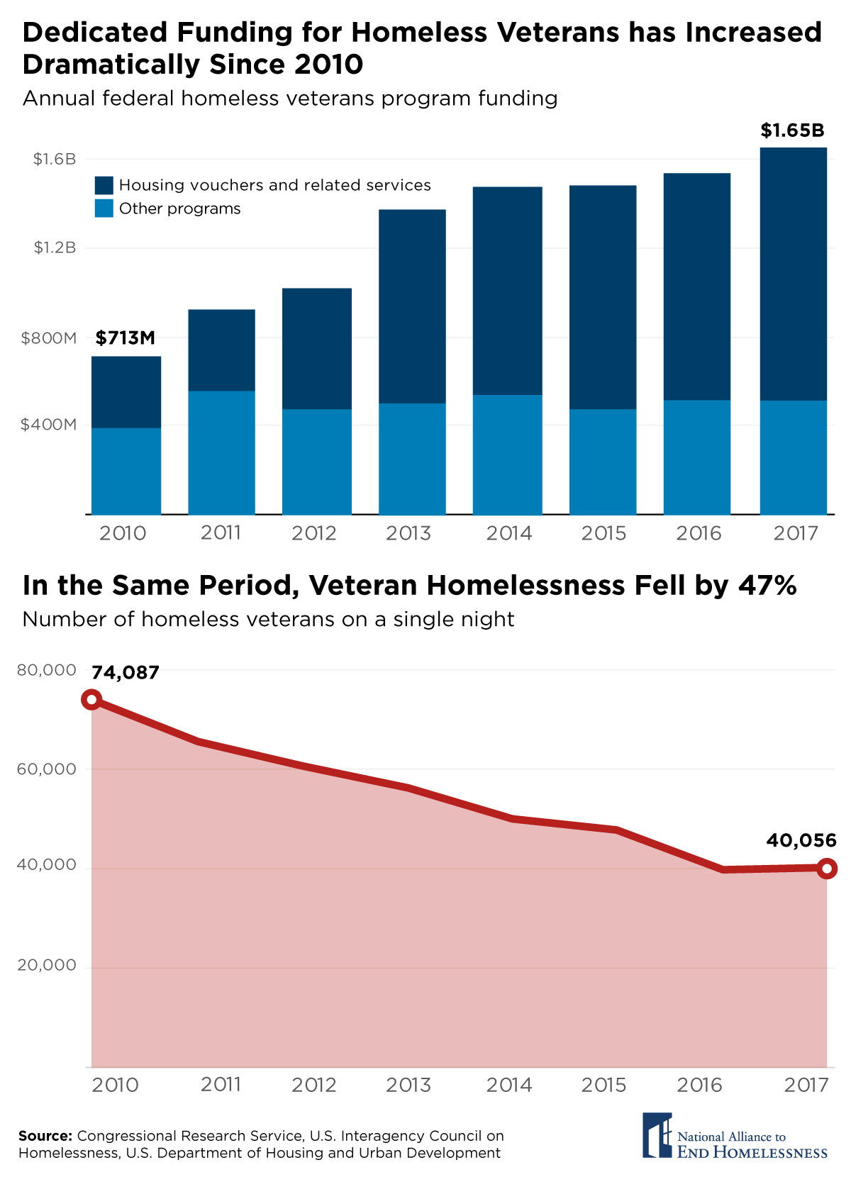

**Conclusion**

Veterans can come from all races, genders, relationship status, military service eras, and military branches and still experience a form of trauma and PTSD that has a positive correlation with veteran homelessness. The trauma that veterans experience can be from many things they experience while being in the military whether it be combat or non-combat. Veterans who become homeless often don’t seek help or feel that they are unable to, which often leads to self-medicating, substance abuse, alcoholism, or continuing to isolate themselves. The feeling of neglect, lack of support, and attempting to treat their trauma themselves are factors that ultimately lead most veterans to homelessness. In order to help veterans who are becoming homeless or are already homeless, organizations like One Roof, find it important to offer more mental health aid and housing outcomes so that these veterans receive the help they need and are able to get back on their feet.

**Further Reading**

National Alliance to End Homelessness, “[5 Key Facts About Homeless Veterans](https://endhomelessness.org/blog/5-key-facts-about-homeless-veterans/)”

VeryWellMind, “[Homeless Veterans Living With PTSD](https://www.verywellmind.com/homeless-veterans-living-with-ptsd-4164824)”

Houses For Warriors, “[The Ugly Connection Between PTSD and Homelessness](https://housesforwarriors.org/the-ugly-connection-between-ptsd-and-homelessness/)”

“[Comparing Trauma Treatment Outcomes Between Homeless Veterans and Housed Veterans in a VA PTSD Clinical Program](https://link.springer.com/article/10.1007/s10597-022-01061-2)”

VeteranAddiction.org, “[Veteran Homelessness: Risks, Statistics & Assistance Programs](https://veteranaddiction.org/resources/homeless-veterans/)”