

Sports Journalism Rising Opportunities at Auburn

AUBURN, Ala. - Auburn University’s School of Communication and Journalism is offering unique opportunities for students whose focus is journalism and have an interest in sports or sports production. These rising opportunities are offering students new ways to get involved in the sports journalism world and get hands-on experience in unique ways.

“Students who love collegiate and professional sports and want to be part of the production teams who deliver live sporting events to our homes and mobile devices will be interested in the Sports Production track (JRSP)” , says the [Auburn CMJN website](https://cla.auburn.edu/cmjn/journalism-sports-production/jrnl-sports-production-track/).

These opportunities allow students to get hands-on experience by not only the course material but also getting professional training from [faculty who have decades of experience in the sports field](https://cla.auburn.edu/cmjn/journalism-sports-production/).

These opportunities also include working with Auburn’s War Eagle Productions which produce many live events every year including events at Auburn, SEC, ESPN, etc.

Grace Renolds, a student focused on the sports production route at Auburn’s College of Communication and Journalism stated how the sports production opportunity Auburn offers has given her “the most practical experience she could have gotten”.

For young journalists coming out of school, with a focus on sports, this is making them extremely valuable to future employers because of the new experiences and opportunities at Auburn.

Hannah Lester talks about how journalism is a field of “getting out of your comfort zone and learning to grow and getting to experience so many different things everyday”.

With the courses taught and work experiences with War Eagle Productions, [Auburn's reputation for training high-quality students in live sports production has only increased as students graduate with professional-level skill sets](https://cla.auburn.edu/cmjn/journalism-sports-production/jrnl-sports-production-track/).

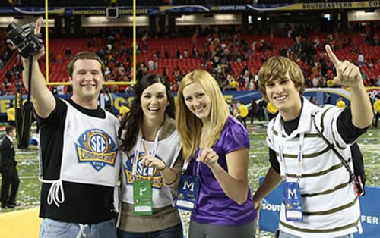

Auburn Students getting professional experience doing sports production for the SEC from [Auburn’s CMJN website.](https://cla.auburn.edu/cmjn/journalism-sports-production/)

These new and exciting opportunities are what give Auburn students the opportunity to get the help they need in college to pursue a successful career in sports production and sports journalism.

Ellie Andrews

Director of Public Relations

[eha0012@auburn.edu](mailto:eha0012@auburn.edu)

469-815-5953